# Roman Numerals Kata

## Slide 12: Set Up Java Project

Extract project from RomanConversionStarting to project directory. Recommend this be done ahead of presentation where you can show only one class set up so far

## Slide 15: Let’s Get Coding – Refactoring Specs

Create a file called RomanNumerals.feature in the src/test/resources/cucumber/kata directory:

**Feature: In order to reduce confusion with Roman Numerals**

**As A reader of roman numerals**

**I want to translate the numbers to Arabic numbers**

**Scenario Outline:** translate simple numbers to Arabic  
 **When** I ask for a translation of a "<Roman Numeral>"  
 **Then** I get the correct "<Arabic Number>"  
 **Examples:  
 |** *Roman Numeral* **|** *Arabic Number* **|  
 | I | 1 |  
 | V | 5 |  
 | X | 10 |  
 | L | 50 |  
 | C | 100 |  
 | D | 500 |  
 | M | 1,000|**

Now lets create a separate feature file that will hold the error handling, call it RomanNumeralErrors.feature file with this description:

**Feature**: **In order to reduce confusion with incorrect numbers**

**As A user of roman numerals**

**I want to capture incorrect translation attempts**

**Scenario Outline:** translation error numbers  
 **When** I ask for a translation of a "<Roman Numeral>"  
 **Then** I get the invalid numeral error  
 **Examples:  
 |** *Roman Numeral* **|  
 | B |  
 | # |  
 | 2 |**

Move the errors from above into this feature file.

## Slide 17: IDE Will Generate Glue Stubs

Use Intellij to generate the step definition stubs. Demo the creation of the step definition

Key item is the class name of **TestRomanNumeralFeatureSteps** and java (not Java 8) coding style into the **test\java\cucumber\kata\step_definitions** directory. Ensure it is in the **cucumber.kata** package!

Now we need the code to make use of this helper class in the testing (variables and two method bodies):

(add now to speed up coding process)

**private** ConversionEntry **aRomanConversion**;  
**private** ConversionEntry **aComplexConversion**;  
**private** ConversionEntry **anErrorConversion**;  
**private** ConversionEntry **anArabicConversion**;

Code for the When clause:

**aRomanConversion** = **new** ConversionEntry();  
**aRomanConversion**.setRomanNumeral(romanNumeral);  
*//no test done, this is setup for the next step*

Code for the Then clause:

*assertEquals*(Long.*valueOf*(anArabicNumber), Long.valueOf(RomanNumbers.toArabic(**aRomanConversion**.getRomanNumeral())));

## Slide 18: Using Examples in Spec

First the helper **test** class to hold values from When to Then clause:

*//helper class*

public class ConversionEntry {

private String romanNumeral;

private Integer arabicNumber;

public void setRomanNumeral(String romanNumeral) {

this.romanNumeral = romanNumeral;

}

public void setArabicNumber(int anArabicNumber) {

this.arabicNumber = anArabicNumber;

}

public String getRomanNumeral() {

return romanNumeral;

}

public int getArabicNumber() {

return arabicNumber;

}

}

## Slide 20: Let’s Get Coding - TDD

Add a class to run the unit tests **TestRomanNumeralUnitTests**:

package cucumber.kata.junit;

/**

* Created by Shane on 3/1/2017.

*/

public class **TestRomanNumeralUnitTests** {

@Test

public void testSimpleArabicToRoman () {

*assertEquals*(**"1 should be the outcome"**,1, RomanNumbers.*toArabic*(**"I"**));  
*assertEquals*(**"5 should be the outcome"**,5, RomanNumbers.*toArabic*(**"V"**));

}

}

## Slide 21: Now For Application Coding

Now to start coding in the application, add:

* The directory **main**, then **java** under src
* Add the package **cucumber.kata** to the java directory
* Now add the class ~src/main/java/cucumber/kata **RomanNumbers**

Put this class method in:

public static long toArabic(String aRomanNumber) throws IllegalArgumentException{

RomanNumeral aRomanNumeral = RomanNumeral.valueOf(aRomanNumber);

switch (aRomanNumeral) {

case I:

return RomanNumeral.I.getArabic();

case V:

return RomanNumeral.V.getArabic();

default:

throw new IllegalArgumentException("Invalid Digit " + aRomanNumber);

}

}

I decided to use an enum as part of my design – thus the “Design” aspect of TDD. Add java class file called /src/main/java/cucumber/kata/RomanNumeral:

**package** cucumber.kata;

public enum RomanNumeral {

V(5,"V"),

I(1,"I");

private int arabic;

private String name;

private RomanNumeral(int arabic, String name){

this.arabic = arabic;

this.name = name;

}

public int getArabic() {

return arabic;

}

public String getName() {

return name;

}

}

Now use the IDE to fix the remaining compilation errors by having it generate the import lines. Once all of the errors are clear, we can try running the **UNIT** test.

Now we can run our acceptance test, based on what we copied in from our story. Now **two of our acceptance tests pass**! We are on the right track.

## Slide 17 to Slide 24: Our Testing Allocation Decision

Now get more of the acceptance tests to pass:

* Talk about **the three amigos evaluating and deciding on a test approach to balance unit and functional tests**. Basically do the minimum on unit tests as the functional tests cover a lot of territory.
* We will use the unit tests to drive the rough design, but leave the full scope to the functional tests.

Update our basic translation code in the RomanNumbers class:

case X:

return RomanNumeral.X.getArabic();

case C:

return RomanNumeral.C.getArabic();

case D:

return RomanNumeral.D.getArabic();

case M:

return RomanNumeral.M.getArabic();

case L:

return RomanNumeral.L.getArabic();

And lets fix up the enum to contain the rest of the definitions:

// sequence is important here

M(1000, "M"),

CM(900, "CM"),

D(500,"D"),

CD(400,"CD"),

C(100, "C"),

XC(90,"XC"),

L(50,"L"),

XL(40,"XL"),

X(10,"X"),

IX(9,"IX"),

V(5,"V"),

IV(4,"IV"),

I(1,"I");

On code coverage, Now go ahead and run with coverage. Wow, that is cool!

## Slide 25: On To Complex Numbers

Here is the spec:

Scenario Outline: translate common number combinations

When I ask for a translation of a combination "<Complex Roman Numeral>"

Then I get the correct combination translation "<Arabic Number>"

Examples:

| Complex Roman Numeral | Arabic Number |

| IV | 4 |

| IX | 9 |

| XC | 90 |

| XL | 40 |

| CD | 400 |

| CM | 900 |

| MMXIII | 2013 |

| MMMCMXCIX | 3999 |

Generate the steps for complex Roman Numerals into the same class **TestRomanNumeralFeatureSteps**.

Code for When (remember to adjust the input parameter name:

aComplexConversion = new ConversionEntry();

aComplexConversion.setRomanNumeral(romanNumeral);

//no test done, this is setup for the next step

Code for Then:

assertEquals(Long.valueOf(anArabicNumber), *assertEquals*(Long.*valueOf*(anArabicNumber), Long.*valueOf*(RomanNumbers.*toArabic*(**aComplexConversion**.getRomanNumeral())));

Now we have more failing functional tests. Need to write another unit test so I can write some more code!

## Slide 26: Code for Complex Numbers

We have our functional test failing – our design does not cover complex numbers. Now to create a unit test to drive this part of our design by adding this unit test to **TestRomanNumeralUnitTests**:

@Test

public void testComplexArabicToRoman () {

*assertEquals*(**"256 should be the outcome"**, 256, RomanNumbers.*toArabic*(**"CCLVI"**) );

}

When I run this test, it now fails – there is not a enum of CCLVI. Now **back to refactoring** and getting rid of the case statement in **RomanNumbers**:

public static long toArabic(String aRomanNumber) throws IllegalArgumentException{

int arabic = 0;

String romanName;

for (RomanNumeral currentRomanNumber : RomanNumeral.values()) { //Iterate through all of the enums

romanName = currentRomanNumber.getName();

while (aRomanNumber.startsWith(romanName)) { //We might have many instances of the same letter(s)

arabic += currentRomanNumber.getArabic(); //based on finding a match, grab the associated value

aRomanNumber = aRomanNumber.substring(romanName.length()); //remove the letter(s) we just found

}

}

if (aRomanNumber.length() > 0) {

throw new IllegalArgumentException("Invalid Digit " + aRomanNumber); //if we have anything left over, that is bad

}

return arabic;

}

Now the unit tests and functional tests work.

## Slide 29: Refactoring Edge Specs

Move **all** of the error handling specs into the **RomanNumeralErrors.feature** file.

**Feature:** In order to reduce confusion with incorrect numbers  
 As A user of roman numerals  
 I want to capture incorrect translation attempts

Scenario Outline: translation error numbers

When I ask for a translation of an invalid "<Roman Numeral>"

Then I get the invalid numeral error

Examples:

| Roman Numeral |

| B |

| # |

| 2 |

Scenario Outline: flag malformed numbers

When I ask for a translation of an invalid "<Bad Roman Numeral>"

Then I get the invalid numeral error

Examples:

| Bad Roman Numeral |

| VC |

| LD |

| IIXV |

| IC |

| CM |

| XD |

| XM |

Scenario Outline: flag bad Arabic numbers

When I ask for a Roman translation of a invalid "<Bad Arabic Numeral>"

Then I get the invalid Arabic error

Examples:

| Bad Arabic Numeral |

| 0 |

| 4000 |

## Slide 30: Add Roman Error Step/Glue Code

Now add code for translation error numbers.

For when:

anErrorConversion = new ConversionEntry();

anErrorConversion.setRomanNumeral(romanNumeral);

//no test done, this is setup for the next step

Code for then:

**try** {  
 RomanNumbers.*toArabic*(**anErrorConversion**.getRomanNumeral());  
 *fail*(**"Invalid RomanNumeral, no exception thrown."**); *//if the exception is not thrown, then this code will run*}  
**catch** (IllegalArgumentException e) {  
 *//do nothing here as the exception was expected*}

Add **two** error unit tests: A simple error unit test:

@Test  
**public void** testInvalidRomanNumeralB() {  
 **try** {  
 RomanNumbers.*toArabic*(**"B"**);  
 *fail*(**"Invalid Digit B"**);  
 }  
 **catch** (IllegalArgumentException expectedException)  
 {*//do nothing* }  
}

Let’s add our second unit test to cover complex number errors:

@Test  
**public void** testInvalidRomanNumeralComboVC() {  
 **try** {  
 RomanNumbers.*toArabic*(**"VC"**);  
 *fail*(**"Invalid Digit C"**);  
 }  
 **catch** (IllegalArgumentException expectedException)  
 {*//do nothing* }  
}

Now run and eliminate **surprise error in specs**. “CM” is a valid combination!

# Slide 32: Now Arabic to Roman Code

Last bit of acceptance criteria – story 4. Add the following to specify the normal flow from Roman Numeral to Arabic number feature file.

Scenario Outline: translate simple numbers to Roman

When I ask for a Roman translation of a "<Arabic Number>"

Then I get the correct Roman Numeral "<Roman Numeral>"

Examples:

| Arabic Number | Roman Numeral |

| 1 | I |

| 5 | V |

| 256 | CCLVI |

| 1001 | MI |

| 1993 | MCMXCI |

Now add the step code to **TestRomanNumeralFeature** and see the test fail:

Here is the When code:

anArabicConversion = new ConversionEntry();

anArabicConversion.setArabicNumber(Integer.parseInt(anArabicNumber));

//no test done, this is setup for the next step

Now the Then code:

assertEquals(aRomanNumber, RomanNumbers.toRoman(anArabicConversion.getArabicNumber()));

Won’t compile as we need a **new method**.

Add this unit test to **TestRomanNumeralUnitTests**:

@Test

public void testArabicToRoman () {

*assertEquals*(**"I should be the outcome"**, **"I"**, RomanNumbers.*toRoman*(1));  
*assertEquals*(**"V should be the outcome"**, **"V"**, RomanNumbers.*toRoman*(5));

}

## Slide 33: Arabic to Roman Code

Add the following method to **RomanNumbers** class:

public static String toRoman(int arabic) {

StringBuilder result = new StringBuilder();

for (RomanNumeral numeral : RomanNumeral.values()) { //Iterate through all of the enums, large to small

while (arabic >= numeral.getArabic()) { //starting with the larger values, subtract them out

arabic -= numeral.getArabic(); //reduce number with matching number

result.append(numeral.name()); //append found roman value

}

}

return result.toString();

}

## Slide 34: Fix the Specs

Change the spec to this:

| 1993 | MCMXCIII |

## Slide 35: Arabic Error Step Code

Add step test code to **TestRomanNumeralFeatureSteps** :

Code for When:

**anArabicConversion** = **new** ConversionEntry();  
**anArabicConversion**.setArabicNumber(Integer.*parseInt*(anArabicNumber));  
*//no test done, this is setup for the next step*

Code for When:

**try** {  
 RomanNumbers.*toRoman*(**anArabicConversion**.getArabicNumber());  
 *fail*(**"Invalid Arabic Numeral, no exception raised."**);  
 }  
 **catch** (IllegalArgumentException e) {  
 *//do nothing here as the exception was expected* }

Add a unit test in **TestRomanNumeralUnitTests** to drive the code:

@Test

public void testInvalidRomanNumeralOne() {

try {

RomanNumbers.toRoman(0);

fail("Only numbers between 1 and 3999 is supported.");

}

catch (IllegalArgumentException expectedException)

{//do nothing

}

}

This test fails, we should have seen an exception. So let’s add the code to get the correct exception in **RomanNumbers**:

New variables in the class:

private static final int LOWER_NUMERAL_LIMIT = 1;

private static final int UPPER_NUMERAL_LIMIT = 3999;

New code:

**public static** String toRoman(**int** arabic)**throws** IllegalArgumentException {

//this is the new code to create the exception  
 **if** (arabic < ***LOWER_NUMERAL_LIMIT*** || arabic > ***UPPER_NUMERAL_LIMIT***) {  
 **throw new** IllegalArgumentException(String.*format*(**"Only numbers between %s and %s is supported."**, ***LOWER_NUMERAL_LIMIT***, ***UPPER_NUMERAL_LIMIT***));  
 }

StringBuilder result = **new** StringBuilder();  
 **for** (RomanNumeral numeral : RomanNumeral.*values*()) { *//Iterate through all of the enums, large to small* **while** (arabic >= numeral.getArabic()) { *//starting with the larger values, subtract them out* arabic -= numeral.getArabic(); *//reduce number with matching number* result.append(numeral.name()); *//append found roman value* }  
 }  
 **return** result.toString();  
}

We have completed the coding. Now re-check the **code coverage** and finish up with the slides.

Scroll through the tests results, showing all of the business rule examples and the count of tests.

[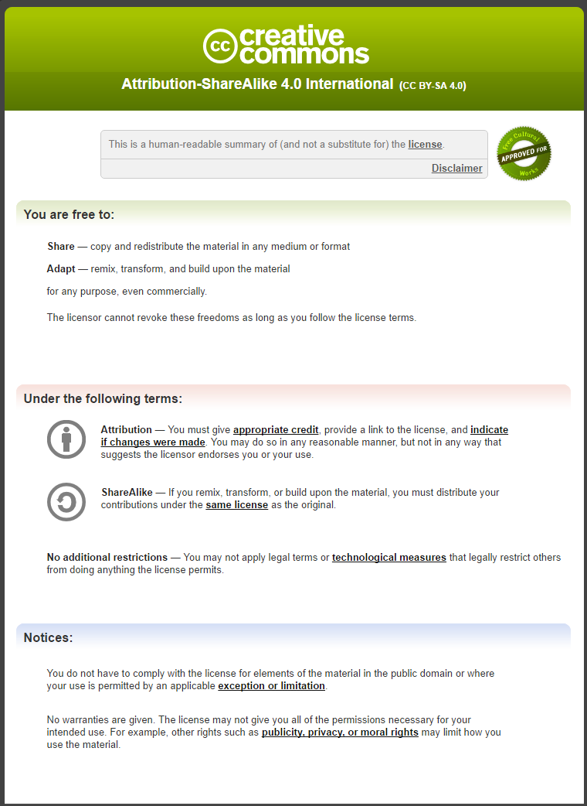](https://creativecommons.org/licenses/by-sa/4.0/)